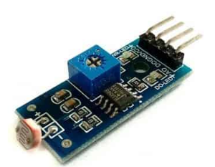

3.3V

GND

ADC (GPIO 26)

Wiring the Light Sensor

Pico W

VCC

GND

A0